PROJECT SUMMARY
[MinnickNealigh2014July/1208]
16 October 2014

OBJECTIVE
- Continue from the MinnickHenry2014Mar project, seeking to extend the Minnick line into Germany.

RESULTS
- Found Michael Minnich’s death record and a photograph of his tombstone. These records give his birth and death dates.
- Found Michael Minnich in U.S. census records to confirm his residence and seek family members who lived nearby.
- Discovered there were two Michael Minnichs who were about the same age in census records. Both lived in York County, Pennsylvania, prior to 1800. But after 1800, one lived in York and the other lived in Menallen, Adams, Pennsylvania. The ancestral Michael Minnich is the one who lived in Menallen.
- Found the will of Simon Minich of Strasburg Township, York, Pennsylvania. This document indicates he had a son named Michael. Concluded Simon’s son Michael was the one who lived in York County, not Adams County. Thus, he was not the ancestor.
- Discovered that John Michael Minnich, a Revolutionary War veteran of Lancaster County, Pennsylvania, died in 1800 in Shrewsbury, York, Pennsylvania. His probate documents confirm he also had a son named Michael. There were only two Michael Minnichs in York County, Pennsylvania, in 1800: the ancestor and the son of Simon Minich. Since the ancestor was not the son of Simon Minich, he must have been the son of John Michael Minnich.
- Learned that John Michael Minnich was the son of Peter Münch (1698-1766), who settled in Bethel Township, Lancaster, Pennsylvania.
- Identified the children of Peter Münch. One of them was Simon Minich of York County. Thus, the Michael Minnichs of York and Adams Counties were first cousins.
- Learned that Peter Münch and Simon Münch, his brother, came to America on the ship Samuel from Rotterdam, arriving at Philadelphia on 30 August 1737. Gottfried Münch and Conrad Münch were probably other brothers; they came to America later.
- Confirmed that Conrad and Gottfried Münch were from Mechtersheim, near Speyer, in the Kingdom of Bavaria, Germany. So if they were Peter’s brothers as is suspected, then Peter Münch was also from Mechtersheim.
- Learned interesting history of the early Münch families.
- Sought to extend the ancestry of Catharine Nealigh, wife of Michael Minnich. Concluded that Heinrich Nehlig (1767-1848) was probably her brother.
- Found a convincing candidate to have been the father of both Catharine and Henry Nealigh: Joseph Neely/Nehlich of Tyrone Township, York, Pennsylvania. Joseph’s will includes multiple pieces of evidence that suggest it pertains to the ancestral family. However, one piece of conflicting evidence exists. Additional research is needed to figure out exactly how he was related to the ancestral family.

RECOMMENDATIONS
- Future research on the Münch ancestry should be turned over to our German expert to seek the Münch family in Mechtersheim, Bavaria, Germany.
- Seek additional probate documents and other records pertaining to Joseph Neely to try to determine exactly how he was related to the ancestral family. For now, he has been tentatively added to the client database, pending further research.

RESEARCH REPORT
[MinnickNealigh2014July/1208]
16 October 2014

The objective of this project was to continue from the MinnickHenry2014Mar project, seeking to extend the Minnick line into Germany.

Michael Minnich (1760-1847)
When Michael Minnich wrote his will on 20 June 1843, he lived in Menallen Township, Adams, Pennsylvania. It was suspected he died in early 1847, since his will was proved in court 18 February 1847. In fact, this is what happened. His death was recorded in the Holy Trinity Lutheran Church in York Springs, Adams, Pennsylvania. He died 16 February 1847 at age 86 years 8 months 16 days and was buried at Benders Cemetery (calculated birth date 31 May 1760).
A photograph of Michael Minnich’s tombstone was found, and it indicates he died 14 February 1847 at age 86 years 8 months 19 days (calculated birth date 26 May 1760). Michael was buried at Benders Lutheran Church Cemetery in Biglerville, Adams, Pennsylvania, next to his wife Catharine.

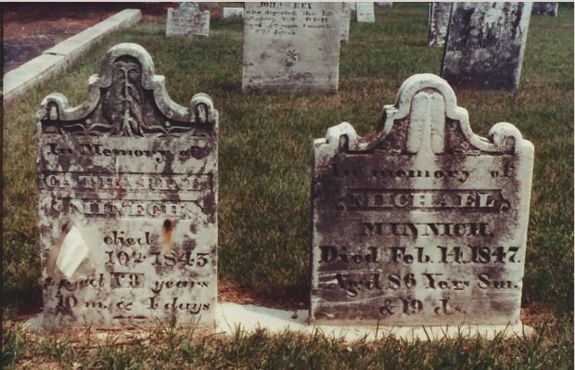
Side-by-Side Tombstones of Michael Minnich and Catharine Minnich
Benders Lutheran Church Cemetery, Biglerville, Adams, Pennsylvania

Michael Minnich was sought in U.S. census records to confirm his residence each decade and seek family members who may have lived nearby. It was quickly noted that the 1800 census includes two Michael Minnichs who were age 26-44. One lived in York, York County, and the other lived in Menallen, Adams County. Following is a breakdown of each household by age group and gender. It is apparent that the ancestral Michael Minnich’s household does not fit the York County configuration—six female slots are missing. However, his family fits nicely in the Adams County configuration.

Locality |  | 1800, York, York, Pennsylvania
 |  |  | Free White Males |  |  |  |  | Free White Females
Page | Line | Head of Family | 0  to  10 | 10  to  16 | 16  to  26 | 26  to  45 | 45  + | 0  to  10 | 10  to  16 | 16  to  26 | 26  to  45 | 45  + | All Others | Slaves
 |  | Michael Minick | 2 |  |  | 1 |  |  |  | 1
1800 U.S. Census, York, York, Pennsylvania
Male 0-10 could be George Minnich, b. 1793
Male 0-10 could be Michael Minnich, b. 1797
Male 26-44 could be Michael Minnich, b. 1760
Female 16-25 ? [spouse? wrong age to be Catharine]

In the York County household shown above, there are no tally marks for six of the females that should have been in the home at this time: wife Catharine, b. Abt 1764; Catherine Minnich, b. 1786; Barbara Minnich, b. 1788; Elisabeth Minnich, b. 1791; Rebecca Minnich, b. 1795; and Maria Magdalena “Margaret” Minnich, b. 1800. However, all family members fit nicely in the Adams County household, shown below.

Locality |  | 1800, Menallen, Adams, Pennsylvania
 |  |  | Free White Males |  |  |  |  | Free White Females
Page | Line | Head of Family | 0  to  10 | 10  to  16 | 16  to  26 | 26  to  45 | 45  + | 0  to  10 | 10  to  16 | 16  to  26 | 26  to  45 | 45  + | All Others | Slaves
 |  | Michael Minich | 2 |  | 3 | 1 |  | 2 | 2 |  | 1

1800 U.S. Census, Menallen, Adams, Pennsylvania
Male 0-10 George Minnich, b. 1793
Male 0-10 Michael Minnich, b. 1797
Male 16-25 ? [hired laborer?]
Male 16-25 ? [hired laborer?]
Male 16-25 ? [hired laborer?]
Male 26-44 Michael Minnich, b. 1760
Female 0-10 Elisabeth Minnich, b. 1791
Female 0-10 Rebecca Minnich, b. 1795
Female 10-15 Catherine Minnich, b. 1786
Female 10-15 Barbara Minnich, b. 1788
Female 26-44 Catharine Minnich, b. Abt 1764

Michael Minnich was then found on the 1810, 1820, 1830, and 1840 U.S. censuses of Menallen Township, Adams, Pennsylvania. These censuses confirm that he remained in Menallen Township from at least 1800 until his death in 1847. They also show that at certain times, some of his sons and/or sons-in-law lived near him, yet in no case did his son Michael ever live near him as an adult. This is consistent with the conclusion that the ancestral Michael Minnick, who moved to Indiana, was his son.

Locality |  | 1810, Menallen, Adams, Pennsylvania
 |  |  | Free White Males |  |  |  |  | Free White Females
Page | Line | Head of Family | 0  to  10 | 10  to  16 | 16  to  26 | 26  to  45 | 45  + | 0  to  10 | 10  to  16 | 16  to  26 | 26  to  45 | 45  + | All Others | Slaves
 |  | Michael Menach | 2 | 2 |  |  | 1 | 1 | 2 | 1 | 1 | 1

1810 U.S. Census, Menallen, Adams, Pennsylvania
Male 0-10 Daniel Minnich, b. 1803
Male 0-10 John Minnich, b. 1806
Male 10-16 George Minnich, b. 1793
Male 10-16 Michael Minnich, b. 1797
Male 45+ Michael Minnich, b. 1760
Female 0-10 Maria Magdalena Minnich, b. 1800
Female 10-16 Elisabeth Minnich, b. 1791
Female 10-16 Rebecca Minnich, b. 1795
Female 16-26 Barbara Minnich, b. 1788
Female 26-45 ?
Female 45+ Catharine Minnich, b. Abt 1764

Locality |  | 1820, Menallen, Adams, Pennsylvania
 |  |  | Free White Males |  |  |  |  |  | Free White Females
Page | Line | Head-of-Family | 0  to  10 | 10  to  16 | 16  to  18 | 16  to  26 | 26  to  45 | 45  + | 0  to  10 | 10  to  16 | 16  to  26 | 26  to  45 | 45  + | All Others | Slaves
 |  | George Minoch |  |  | 1 | 1 | 1 |  | 1 |  | 1
 |  | Michail Minoch |  | 2 | 1 | 2 |  | 1 |  | 1 | 1 |  | 1

1820 U.S. Census, Menallen, Adams, Pennsylvania
Male 10-16 Henry S. Minnich, b. 1808
Male 10-16 John Minnich, b. 1806
Male 16-18 Daniel Minnich, b. 1803
Male 16-26 Daniel Minnich, b. 1803
Male 16-26 ? [hired laborer?]
Male 45+ Michael Minnich, b. 1760
Female 10-16 ? [grandchild?]
Female 16-26 Maria Magdalena Minnich, b. 1800
Female 45+ Catharine Minnich, b. Abt 1764

Locality |  |  | 1830, Menallen, Adams, Pennsylvania
Pg.  Ln. | Head of Family |  | 0  to  5 | 5  to  10 | 10  to  15 | 15  to  20 | 20  to  30 | 30  to  40 | 40  to  50 | 50  to  60 | 60  to  70 | 70  to  80 | 80  + | Slaves
 | George Menich | M  F | 2 | 1 | 1 |  | 2 | 1  1
 | Daniel Menich | M  F | 2 |  | 1 |  | 1  1
 | Michael Minich | M  F |  |  | 1  1 |  |  |  |  |  | 1  1

1830 U.S. Census, Menallen, Adams, Pennsylvania
Male 10-15 ? [grandchild?]
Male 60-70 Michael Minnich, b. 1760
Female 10-15 ? [grandchild?]
Female 60-70 Catharine Minnich, b. Abt 1764

Locality |  |  | 1840, Menallen, Adams, Pennsylvania
Pg.  Ln. | Head of Family |  | 0  to  5 | 5  to  10 | 10  to  15 | 15  to  20 | 20  to  30 | 30  to  40 | 40  to  50 | 50  to  60 | 60  to  70 | 70  to  80 | 80  + | Slaves
 | George Minich | M  F | 1 | 1 | 1 | 2 | 1 | 1 | 1
 | Michl Minich | M  F |  |  |  |  | 2 |  |  |  |  | 1 | 1
 | William Rex | M  F | 1  2 | 2 | 1 | 2  1 |  |  | 1 | 1

1840 U.S. Census, Menallen, Adams, Pennsylvania
Male 20-30 ? [hired laborer?]
Male 20-30 ? [hired laborer?]
Male 80-90 Michael Minnich, b. 1760
Female 70-80 Catharine Minnich, b. Abt 1764

The Michael Minnich who was enumerated in York, York, Pennsylvania, in 1800 remained in York County and was enumerated in the census there in 1810, 1830, and 1840. He was listed near a few other Minnichs, including George (1810), Jonathan (1800, 1810, 1830), Simon (1810), John (1840), Jacob (1840), and Henry (1840).

The Father of Michael Minnich
An online family tree claims the ancestral Michael Minnich was the son of Simon Minich and Catherine Elizabeth. Simon Minich of Strasburg Township, York, Pennsylvania, wrote his will on 27 October 1794—the document is entirely in German. Following is an abstract of it, translated into English:

Will of Simon Minich of Strasburg Township, York, Pennsylvania
Dated: 27 Oct 1794
Proved: 6 Dec 1797
Wife: Catarina Elisabetha
Children: Simon Minich, Michael Minich, Catarina Hartman, Philip Minich, Christina Miller, Peter Minich, Jacob Minich, Johannes Minich, Benjamin Minich
Executors: sons Simon Minich and Michael Minich, both living in York
Witnesses: Nicolaus Sintz (or Hintz), Henrich Alt

This will establishes that Simon Minich did have a son named Michael. However, his son Michael was living in York County in 1794. This would seem to suggest that Simon’s son was the Michael Minnich who was enumerated in York County from 1800 to 1840, rather than the Michael Minnich who lived in Adams County from 1800 to 1840. The problem is that Adams County was created from York County in 1800, meaning that in 1794, both Michael Minnichs probably lived in York County.

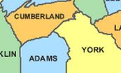
Map of Cumberland, York, and Adams Counties, Pennsylvania

Evidence that clarifies which Michael Minnich was Simon’s son was found by studying the cluster of Minnichs who associated with each Michael. The Michael Minnich who lived in Adams County was never enumerated near another Minnich of his age or older—just his own sons. However, the Michael Minnich who remained in York County after 1800 lived near Simon, Jonathan, and Jacob Minnich, all of whom were sons of Simon Minich. This suggests that Simon’s son Michael was the man who lived in York County from 1800 to 1840 near his brothers. Thus, Simon Minich was not the father of the ancestor. However, it was suspected that he was related to the ancestor in some way, since both Minnich families lived so close to each other and followed similar naming patterns.
Michael Minnich (1760-1847) can be found on twelve different online family trees at Ancestry.com. Though several of the trees do not connect him to any parents and one incorrectly links him to Simon Minich, six of the trees claim he was the son of John Michael Minnich (Münch), who was born 2 January 1738 in Lancaster County, Pennsylvania, and died in March 1800 in York, Pennsylvania. According to these trees, John Michael Minnich was married to Maria Christina Laudig, who was born about 1740 and died in 1800 in Shrewsbury, York, Pennsylvania. None of the trees offers evidence to prove this relationship. Therefore, research efforts sought to prove whether this linkage was correct.
It was discovered that John Michael Minnich served in the Revolutionary War. This is established by his entry in the DAR Patriot Index:

MINNICH, Michael: b. 1-2-1738 PA d. 5 - - 1800 PA m (1) Maria Christina Laudig LT PA

Though the DAR Patriot Index doesn’t specify where in Pennsylvania John Michael Minnich lived, other sources do. For instance, John Michael Muench’s baptismal record, which confirms his birth date as 2 January 1738, indicates he was baptized 24 January 1738 in Tulpehocken, Lancaster, Pennsylvania, as the son of Peter Muench. Peter’s wife was named Christina.
Annual Proceedings, Pennsylvania Society of the Sons of the Revolution, 1919-1920 says Michael Minnich served as second lieutenant in Captain George Null’s Company, First Battalion, Lancaster County, Pennsylvania, Militia, under Colonel Philip Lorentz Greenwalt, from 1776 to 1777. Blue Book of Schuylkill County, Pennsylvania, offers the following about John Michael Minnich:

He took the oath of allegiance, October 12, 1777. The roster of this company has never been found. Egle’s History, Dauphin and Lebanon Counties, says, p. 38: “1775 a battalion with the following officers was formed, Capt. Geo. Null’s company, first organized. Were in active service, 1776, and in the retreat of Gen. Washington, in New Jersey, (p. 52) and at the battle of Trenton, Princeton, Brandywine, Germantown, and at the surrender of Fort Washington, November 16, 1776 (p. 341).

Blue Book of Schuylkill County, Pennsylvania also gives a key piece of evidence: John Michael Minnich eventually settled in Shrewsbury Township, York, Pennsylvania, where he died in 1800. Administration papers were granted to his sons, Michael, Jonathan, and George, 15 April 1800 in Shrewsbury Township. These papers confirm that John Michael had a son named Michael who lived in York County, Pennsylvania, at the same time as the ancestral Michael Minnich! Recall that there were only two Michael Minnichs in York County, Pennsylvania, in 1800: the ancestor and the son of Simon Minich. Since the ancestor was not the son of Simon Minich, he must have been the son of John Michael Minnich!
The children of John Michael Minnich and Maria Christina Ludige, according to Blue Book of Schuylkill County, Pennsylvania, were as follows:

- Michael
- Jonathan
- George
- Joseph
- Elizabeth, wife of Jacob Gladfelter

Peter Münch, the Immigrant
John Michael Minnich was the son of Peter Münch, according to Blue Book of Schuylkill County, Pennsylvania. Peter Münch was born in 1698 and died in 1766. He settled in Bethel Township, Lancaster, Pennsylvania, and took up a tract of land there in 1750. His tract included land on both sides of the Schuylkill River. Peter built a log house on this site, which was located where the Seven Stars hotel now stands in Manheim Township. His log house was burned by Indians in 1755. Later in 1777, Peter’s son Conrad Minnich built the Seven Stars hotel on the property. It was the first public house in the county, and it afforded entertainment and lodging for the patrons of the stagecoach from Philadelphia and Reading to Fort Augusta. Following are two photographs of the Seven Stars hotel, which still stands.
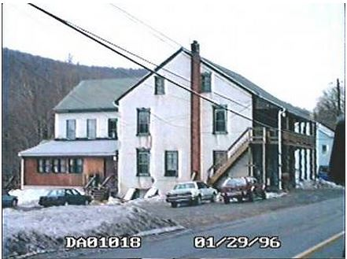
Seven Stars Hotel, North Manheim Township, Schuylkill, Pennsylvania

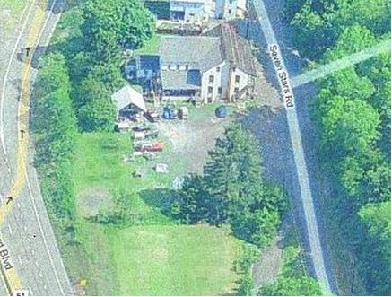
Seven Stars Hotel, North Manheim Township, Schuylkill, Pennsylvania
Peter Münch married twice. With his first wife, Christina Barbara, he had the following children:

- Simon (1728-1795), of York County
- Jacob, of York County
- Henry
- John Michael (1738-1800)
- Peter?
- John Conrad (b. 1740)

So Simon Minich and John Michael Minnich were brothers. This means Simon Minich, who was disproven as the father of Michael Minnich (1760-1847), was actually Michael’s uncle. This makes sense, as it was suspected that the Minnichs of York and Adams Counties were related, due to their proximity to each other for 40+ years.
Peter Münch died in 1766. In his letters of administration, his widow was described as “the widow of Peter Minnich, late of the part of Berks County, which lies over the Blue Mountains, in Pinegrove Township.” An old map shows “Peter’s mountain,” “Minnich’s Gap,” and “Minnich’s Mill.”
Peter Münch and Simon Münch, his brother, came to America on the ship Samuel from Rotterdam, arriving at Philadelphia on 30 August 1737. They located in Tulpehocken Township, Lancaster, Pennsylvania; Peter was 39 years old and Simon was 37. Blue Book of Schuylkill County, Pennsylvania claims Gottfried Münch and Conrad Münch were also brothers of Peter and Simon. Conrad and Gottfried were from Mechtersheim, near Speyer, in the Kingdom of Bavaria, Germany. This is proven by Conrad’s passport:

The passport of Conrad Münch, in possession of J.F. Mynich, Lynbrook, Long Island, N.Y., divested of its technical form, states that: “Conrad Münch, of Mechtersheimer, near Speyer, his wife and his brother Gottfreid Münch do intend to settle in the New England (U.S.)” Then follows the usual form that they should be permitted to “pass without hinderance.” The passport is signed by the “Burgermeister” [mayor] in the name of the “Rath (Town Council) of the free city of Speyer, of the Holy Roman Empire,” April 25, 1765.

Conrad and Gottfried Münch arrived in America 24 August 1765 on the ship Polly, from Rotterdam. They settled in Philadelphia, Pennsylvania. Researchers have concluded that they were no doubt from the same family as the ancestral Münchs who settled in Lancaster and Berks Counties:

The two lines, the Berks County contingent and the descendants of the Philadelphia line are unknown to each other and claim no relationship; yet their ancestral traditions are identical. The same family names occur with little variation through the first and second generations in this country. The letters, too, which follow tell of a misunderstanding between two branches of the Münchs in this country; whether this refers to Gottfried and Conrad, brothers, of Phila., and sons of Gottfried, of Mechtersheim, or as between them and their uncles, (supposedly) Peter and Simon, of Berks County, is not clear; but the two lines were close connections, the proof of it is unquestionable.

Following is a map showing the location of Mechtersheim in Bavaria, Germany.

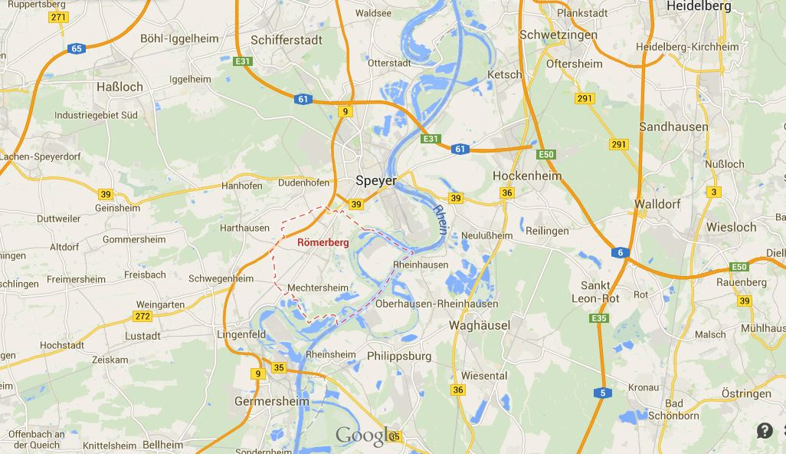
Mechtersheim, Bavaria, Germany

Knowing that Michael Minnich (1760-1847) was the son of John Michael Minnich (1738-1800), and that John Michael Minnich was the son of Peter Münch, makes our last several research projects come full circle. Recall that the client has a copy of the Minnick family Bible, which indicates that Michael Minnick’s father was Peter Matthias Minnick, born 1760, of Philadelphia, Pennsylvania. Though the Bible was proven incorrect when Michael Minnick was established as the son of Michael Minnich (1760-1847), it is now clear that there is some truth in the family Bible after all. Michael Minnick’s great-grandfather was Peter Münch of Philadelphia, Pennsylvania.

History of the Münchs
A history of the early Münchs can be found in Blue Book of Schuylkill County, Pennsylvania .The name Münch means monk or friar. It was derived from an estate, purchased from an order of monks in France.

The early Münchs were Catholics. During the reign of Louis XIV, in France, a Baron Münch, who had embraced the Calvanistic religion and was a powerful factor in the Huguenot political party, was stripped of all his possessions, his chateau burned and he was among those massacred. His kinsmen, after the dissolution of the title, fled to Germany after the revocation of the Edict of Nantes, 1685. Some of the younger men joined the armies at war with France and others, when the opportunity opened later, united with the Palatines and came to America, with their families.

Future research on the Münch ancestry should be turned over to our German expert to seek the Münch family in Mechtersheim, Bavaria, Germany.

The Family of Catharine Nealigh
The remainder of this research project sought to extend the ancestry of Catharine Nealigh, wife of Michael Minnich. Michael’s wife’s name was definitely Catharine. This is evidenced by their son Michael Minnick’s baptismal record (1798), Michael Minnich’s will (1847), and the side-by-side tombstones of Michael and Catharine Minnich in Benders Lutheran Church Cemetery (discussed previously). Several Minnick descendants claim Catharine’s maiden name was Nealigh. It is not clear how her maiden name was learned. A clue to Catharine’s maiden name may have been inferred from the fact that Heinrich Nehlig sponsored the baptism of Catharine’s daughter Elizabeth:

Elisabeth of Mich. Minich and Catharina, b. 8 Oct 1791, c. 17 December 1791. Sponsors: Heinr. Nehlig and wife.

Heinrich Nehlig was christening his own children in the 1790s, so he was too young to have been the father of Catharine Nealigh. But he could have been her brother. He christened his daughter Susan on the exact same day that he sponsored the baptism of Catharine’s daughter Elisabeth.

Susan, d. of Heinr. Nehlib and Elisab., b. 12 Nov 1791, c. 17 Dec 1791. Sponsor: Susana Schlauchin. Upper Bermudian “Ground Oak” Church, Huntington Township, York (now Adams), Pennsylvania.

Elizabeth, d. of Henrich Nelig and wife Elisabeth, b. 4 Apr 1794, c. 27 Apr 1794. Witnesses: Burchardt Wirth and Katharina Schlauchin. Benders Church, York (now Adams), Pennsylvania.

Henry Nehlig migrated to Preble County, Ohio, as shown by the 1820 and 1830 U.S. censuses.

Locality |  | 1820, Harrison, Preble, Ohio
 |  |  | Free White Males |  |  |  |  |  | Free White Females
Page | Line | Head-of-Family | 0  to  10 | 10  to  16 | 16  to  18 | 16  to  26 | 26  to  45 | 45  + | 0  to  10 | 10  to  16 | 16  to  26 | 26  to  45 | 45  + | All Others | Slaves
 |  | Henry Neely | 1 |  |  | 1 |  | 1 | 2 | 2 |  |  | 1

Locality |  |  | 1830, Lewisburg, Preble, Ohio
Pg.  Ln. | Head of Family |  | 0  to  5 | 5  to  10 | 10  to  15 | 15  to  20 | 20  to  30 | 30  to  40 | 40  to  50 | 50  to  60 | 60  to  70 | 70  to  80 | 80  + | Slaves
 | Henry Nalich | M  F

Henry Nealeigh’s tombstone, which is located in the Roselawn Cemetery in Lewisburg, Preble, Ohio, confirms that his wife was named Elizabeth. It also gives his and his wife’s exact birth and death dates. This establishes that he was the right age to have been Catharine’s brother.

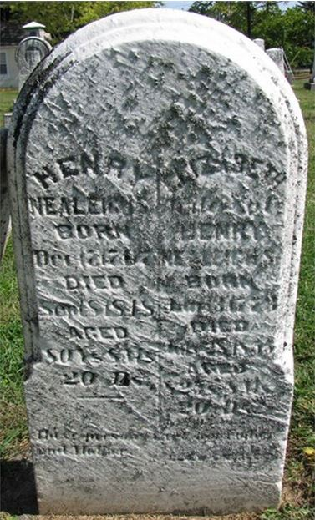
Tombstone of Henry and Elizabeth Nealeigh
Roselawn Cemetery, Lewisburg, Preble, Ohio

Henry Nealeigh Elizabeth, wife of Henry Nealeigh
Born 17 Dec 1767 Born 13 Jan 1773
Died 8 Sep 1848 Died 28 Jul 1855

Since Elizabeth Nealeigh lived past 1850, she was found in the 1850 U.S. census to confirm her birthplace. Indeed, the census indicates she was born in Pennsylvania.
Will records of York County, Pennsylvania, reveal a convincing candidate to have been the father of both Catharine and Henry Nealigh. He was Joseph Nehlich/Neely of Tyrone Township, York, Pennsylvania.

Will of Joseph Neely of Tyrone Township, York, Pennsylvania
Dated: 29 January 1786
Proved: 27 March 1786
“My loving children, four boys and two girls … when they arrive at the age of twenty-one years”
“My four boys shall be put to learn trades when they arrive at the age of fifteen years or at the discretion of their guardians”
Children: Joseph, Peter, Henry, Mary, William, Caterina
Christian Wart guardian for oldest son Joseph Neely
Michel Menick guardian for Peter Neely
George Meals guardian for Henry Neely
Casper Snar guardian for Mary Neely
William Meals guardian for William Neely
Nichles Dedrich Jr. guardian for Caterina Neely
Executor: trusty friend Christen Wart
Witnesses: Thos. McCashlen, Georg Miehl, Michael Minig

This will includes multiple pieces of evidence that suggest it pertains to the ancestral family:

- Among Joseph Neely’s six children were a son and daughter named Henry and Caterina. This suggests Henrich Nehlig and Catharine (Nealigh) Minnich were siblings.
- Michael Menick/Minig is named twice in the will, once as a witness and once when he was appointed guardian for Joseph’s son Peter. Michael may have been Michael Minnich (1760-1847) or his father, John Michael Minnich (1738-1800). In either case, the will provides direct evidence that the Neely and Minnich families were close associates in York County and supports the conclusion that Catharine Minnich, wife of Michael Minnich, was a Nealigh by birth.
- Joseph Neely lived in York County, Pennsylvania, prior to 1800, as would be expected for Catharine (Nealigh) Minnich’s family.

However, one piece of conflicting evidence exists. Notice that the will states, “My four boys shall be put to learn trades when they arrive at the age of fifteen years or at the discretion of their guardians.” It sounds like all four of Joseph’s sons were under age 15, meaning born after 1771. Henry Nealigh’s tombstone gives his birth date as 17 December 1767, which indicates that although he was still a minor when the will was written, he was not under age 15. Future research should seek additional probate documents and other records pertaining to Joseph Neely to try to determine exactly how he was related to the ancestral family. For now, he has been tentatively added to the client database, pending further research.

Conclusion and Recommendations
During this project, the ancestry of Michael Minnich (1760-1847) was extended by two generations, back to the immigrant ancestor, Peter Münch. Peter Münch immigrated to America in 1737, arriving at Philadelphia, and settled in Lancaster County, Pennsylvania. It is believed Peter Münch was originally from Mechtersheim, Bavaria, Germany.
A candidate to have been the father of Catharine (Nealigh) Minnich has been found: Joseph Nehlich/Neely of Tyrone Township, York, Pennsylvania. Several pieces of evidence indicate he was closely related to the ancestral family, but one piece of conflicting evidence may suggest he was not Catharine’s father.
Recommendations for future research include the following:

- Future research on the Münch ancestry should be turned over to our German expert to seek the Münch family in Mechtersheim, Bavaria, Germany.
- Seek additional probate documents and other records pertaining to Joseph Neely to try to determine exactly how he was related to the ancestral family. For now, he has been tentatively added to the client database, pending further research.

It has been a pleasure to assist you in researching your ancestry. We look forward to continuing, according to your instructions.

© 2014 Price and Associates, Incorporated

Minnick2013Oct Research Report, citing Adams County (Pennsylvania) Register of Wills, Register of Wills, 1800-1851; Index to Wills, 1800-1864 (Salt Lake City, Utah: Filmed by the Genealogical Society of Utah, 1950), E:267-270, FHL Film 20678.
“Pennsylvania and New York Church and Town Records, 1708-1985,” Holy Trinity Lutheran Church, York Springs, Adams, Pennsylvania, death of Michael Minich (1847), Ancestry.com (http://www.ancestry.com: accessed 10 October 2014). Document 13.
Cemetery Record of Michael Minnich, Benders Lutheran Church Cemetery, Biglerville, Adams, Pennsylvania, FindAGrave.com (http://www.findagrave.com: accessed 10 October 2014). Documents 1a-1c.
1800 U.S. Census, York, York, Pennsylvania, Michael Minick household, Ancestry.com (http://www.ancestry.com: accessed 10 October 2014). Documents 3a-3c.
1800 U.S. Census, Menallen, Adams, Pennsylvania, Michael Minich household, Ancestry.com (http://www.ancestry.com: accessed 10 October 2014). Documents 4a-4b.
1810 U.S. Census, Menallen, Adams, Pennsylvania, Michael Menach household, Ancestry.com (http://www.ancestry.com: accessed 10 October 2014). Documents 5a-5b.
1820 U.S. Census, Menallen, Adams, Pennsylvania, Michail Minock household, Ancestry.com (http://www.ancestry.com: accessed 10 October 2014). Documents 6a-6b.
1830 U.S. Census, Menallen, Adams, Pennsylvania, Michael Minich household, Ancestry.com (http://www.ancestry.com: accessed 10 October 2014). Documents 7a-7b.
1840 U.S. Census, Menallen, Adams, Pennsylvania, Michl Minich household, Ancestry.com (http://www.ancestry.com: accessed 10 October 2014). Documents 8a-8b.
1810 U.S. Census, York, York, Pennsylvania, Michael Minich household, Ancestry.com (http://www.ancestry.com: accessed 10 October 2014). Documents 9a-9c.
1830 U.S. Census, York, York, Pennsylvania, Michael Minnich household, Ancestry.com (http://www.ancestry.com: accessed 10 October 2014). Documents 10a-10b.
1840 U.S. Census, York, York, Pennsylvania, Michael Minnick household, Ancestry.com (http://www.ancestry.com: accessed 10 October 2014). Documents 11a-11b.
“Family: Michael Minnich/Catherine Nealigh,” TheValleyFamily.org (http://www.thevalleyfamily.org: accessed 25 July 2014). Document 17.
York County (Pennsylvania), Register of Wills, Will Books, 1749-1882; General Index to Wills, 1749-1940 (Salt Lake City, Utah: Filmed by the Genealogical Society of Utah, 1949, 1980), Vol. I-J pp. 394-395, FHL Film 22133. Documents 12a-12b.
“M Marti Family Tree,” “Clapp/Gnuse Family Tree,” “White Family Tree,” “Caton Family Tree,” “Menke Family History Site,” and “Good Family Tree,” Ancestry Public Member Trees, Ancestry.com (http://www.ancestry.com: accessed 10 October 2014).
Daughters of the American Revolution, DAR Patriot Index, Vol. 2 (G-O) (Baltimore, Maryland: Gateway Press, 2003), 1875, FHL Book 973.C42da v.2. Document 14b.
“Baptismal Record of Rev. John Casper Stoever, 1730-1779,” in William Henry Egle, M.D., M.A., ed. Notes and Queries Historical, Biographical, and Genealogical Relating Chiefly to Interior Pennsylvania, Annual Volume,1896 (Baltimore, Maryland: Genealogical Publishing Company, 1970), 28. Document 18c; “Pennsylvania, Lutheran Baptisms and Marriages,” John Michael Muench, Ancestry.com (http://www.ancestry.com: accessed 10 October 2014). Document 19; “Pennsylvania Church Records – Adams, Berks, and Lancaster Counties, 1729-1881,” John Michael Muench, Ancestry.com (http://www.ancestry.com: accessed 10 October 2014). Document 20.
“Baptismal Record of Rev. John Casper Stoever, 1730-1779,” in William Henry Egle, M.D., M.A., ed. Notes and Queries Historical, Biographical, and Genealogical Relating Chiefly to Interior Pennsylvania, Annual Volume,1896 (Baltimore, Maryland: Genealogical Publishing Company, 1970), 56. Document 18d.
Annual Proceedings, Pennsylvania Society of the Sons of the Revolution, 1919-1920 (Philadelphia, Pennsylvania: Sons of the Revolution, 1920), 64-65, Google Books (http://books.google.com: accessed 13 October 2014). Documents 15b-15c.
Ella Zerbey Elliott, Blue Book of Schuylkill County, Pennsylvania (Pottsville, Pennsylvania: Republican, 1916), 378, Google Books (http://books.google.com: accessed 13 October 2014). Document 16q.
Ella Zerbey Elliott, Blue Book of Schuylkill County, Pennsylvania (Pottsville, Pennsylvania: Republican, 1916), 378, Google Books (http://books.google.com: accessed 13 October 2014). Document 16q.
Ella Zerbey Elliott, Blue Book of Schuylkill County, Pennsylvania (Pottsville, Pennsylvania: Republican, 1916), 378, Google Books (http://books.google.com: accessed 13 October 2014). Document 16q.
Ella Zerbey Elliott, Blue Book of Schuylkill County, Pennsylvania (Pottsville, Pennsylvania: Republican, 1916), 366-367, Google Books (http://books.google.com: accessed 13 October 2014). Documents 16d, 16f.
“Seven Stars Hotel, Schuylkill County,” Treasurenet.com (http://www.treasurenet.com/forums/pennsylvania/143981-seven-stars-hotel.html: accessed 14 October 2014).
Ella Zerbey Elliott, Blue Book of Schuylkill County, Pennsylvania (Pottsville, Pennsylvania: Republican, 1916), 366-367, Google Books (http://books.google.com: accessed 13 October 2014). Documents 16d, 16f.
Pennsylvania Traveler Post, Vols. 14-15, page 41, Google Books (http://books.google.com: accessed 14 October 2014).
M.A. Gruber, History of the Minich-Munech-Minnich, etc. Family of Tulpehocken Township, Berks County, Pennsylvania (Salt Lake City, Utah: Filmed by the Genealogical Society of Utah, 1981), FHL Film 1035839 item 6, digitized by FamilySearch.org (http://www.familysearch.org: accessed 14 October 2014). Documents 22a-22n.
Ella Zerbey Elliott, Blue Book of Schuylkill County, Pennsylvania (Pottsville, Pennsylvania: Republican, 1916), 387-388, Google Books (http://books.google.com: accessed 13 October 2014). Documents 16z-16aa.
Ella Zerbey Elliott, Blue Book of Schuylkill County, Pennsylvania (Pottsville, Pennsylvania: Republican, 1916), 366-367, Google Books (http://books.google.com: accessed 13 October 2014). Documents 16d, 16f.
Minnick2013Jan Research Report, citing Family Bible of Mary Emma Zona Minnick Brown, copy obtained by Jay and Tamara Minnick.
Ella Zerbey Elliott, Blue Book of Schuylkill County, Pennsylvania (Pottsville, Pennsylvania: Republican, 1916), 364, Google Books (http://books.google.com: accessed 13 October 2014). Document 16b.
He was born 27 November 1797 and baptized 4 February 1798 in Benders Union Church (Reformed) near Biglerville, Cumberland, Pennsylvania.
Minnick2013Oct Research Report, citing Adams County (Pennsylvania) Register of Wills, Register of Wills, 1800-1851; Index to Wills, 1800-1864 (Salt Lake City, Utah: Filmed by the Genealogical Society of Utah, 1950), E:267-270, FHL Film 20678.
See Ancestry Public Member Trees and Minnick2013Oct Research Report, citing “Family of Michael L. Williams,” FamilyTreeMaker.com (http://familytreemaker.genealogy.com/users/w/i/l/Michael-L-Williams/COL1-0040.html: accessed 7 December 2013).
Minnick2013Oct Research Report, citing Adams County Church Records of the 18th Century: marriages, births, deaths from the earliest record through 1800 of the Dutch Reformed, Episcopalians, Lutherans, Presbyterians, Quakers, Roman Catholics and Reformed (German) (Westminster, Maryland: Family Line Publications, [198?]), v-vi, xi, 56-57, 60-61, 64-65, FHL Book 974.842 K2a.
Adams County Church Records of the 18th Century: marriages, births, deaths from the earliest record through 1800 of the Dutch Reformed, Episcopalians, Lutherans, Presbyterians, Quakers, Roman Catholics and Reformed (German) (Westminster, Maryland: Family Line Publications, [198?]), v-vi, xi, 49, 57, FHL Book 974.842 K2a. Document 21e.
1820 U.S. Census, Harrison, Preble, Ohio, Henry Neely household, Ancestry.com (http://www.ancestry.com: accessed 14 October 2014). Documents 23a-23b.
1830 U.S. Census, Lewisburg, Preble, Ohio, Henry Nalich household, Ancestry.com (http://www.ancestry.com: accessed 14 October 2014). Document 24. The tally marks on this census are illegible.
Tombstone of Henry and Elizabeth Nealeigh, Roselawn Cemetery, Lewisburg, Preble, Ohio, FindAGrave.com (http://www.findagrave.com: accessed 14 October 2014). Documents 25-26.
1850 U.S. Census, Twin Township, Darke, Ohio, William Nealy household, Ancestry.com (http://www.ancestry.com: accessed 14 October 2014). Documents 27a-27b.
Will of Joseph Neely, transcribed in Joseph H. Vance, Warren and Ethel (Garland) Markwith, Their Ancestors, Descendants and Related Families (Lombard, Illinois: J.H. Vance, 1982), 93-94, digitized by FamilySearch.org (http://www.familysearch.org: accessed 14 October 2014). Documents 28a-28c.

