From Patriots to Pioneers:

Exploring Lineage Societies in America’s 250th Year.
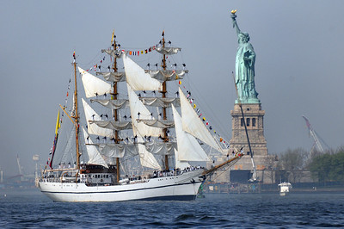
What better way to honor the 250th birthday of the United States of America than by discovering and recognizing your family’s contributions to the foundation of the United States. Lineage societies offer an interesting opportunity to recognize those past contributions and to participate in activities today that will give our descendants reason to celebrate in 2076.
There are many societies to choose from, and their objectives most often encompass education, preservation, and community service. Eligibility requirements are specific to each society, but in general the process requires proven, documented, lineages. Eligibility for membership in a lineage society depends on the specific ancestor from whom you descend. Conversely, membership in a hereditary society it depends on how membership is transmitted through the family line. There is often overlap between these distinctions making it confusing to distinguish between the two. For example, to become a member of the Daughters of the American Revolution you must prove your lineage to a ‘patriot’ and by definition, if you are descended from this patriot, your membership is also hereditary. The objective here is not to dig into the differences between lineage societies and hereditary societies. It is to give an overview of what is available, and what the objectives or ‘raison d’etre’ are for each society.
General Society of Mayflower Descendants (https://themayflowersociety.org/)
Mission: “The General Society of Mayflower Descendants is committed to research on the lineal descent of the Mayflower Pilgrims and education about the Pilgrims who traveled aboard the Mayflower in 1620. The Society provides education and understanding of why the Mayflower Pilgrims were important, how they shaped western civilization, and what their 1620 voyage means today and its impact on the world.”
The Mayflower Society highlights the adventurous nature of their ancestors. There are 54 Member Societies, including Canada, Europe and Australia.
The Mayflower Society is currently working on a project to restore the National Pilgrim Memorial Meetinghouse, formerly known as the First Parish Church of Plymouth.
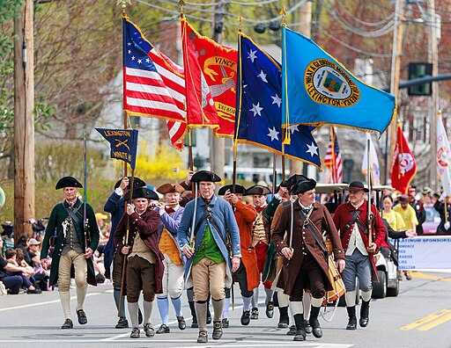

Daughters of the American Revolution https://www.dar.org/
Mission: The National Society Daughters of the American Revolution was founded in 1890. Their website explains “DAR is a nonprofit, nonpolitical volunteer women’s organization dedicated to promoting patriotism, preserving American history and securing America’s future through better education.”
The scope of the work accomplished by the DAR is wide. Expressed in the three umbrella headings, Patriotism, Historic Preservation and Education, they cover scholarships, youth programs, resources for teachers, commemorations and memorials, restoration projects and awards, and service for veterans, to name a few.
Sons of the American Revolution https://www.sar.org/
Mission: “The Sons of the American Revolution honors our Revolutionary War patriot ancestors by promoting patriotism, serving our communities and educating and inspiring future generations about the founding principles of our Country.”
Their landing page contains links to articles such as “Women in the American Revolution,” “African American Participation in the American Revolution,” and “Spanish Ties to the American Revolution.” It also displays their calendar with upcoming events and recent news item.
Colonial Dames of America https://cda1890.org/
The Colonial Dames of America was established in 1890. Colonial Dames of America or DCA as it is also known is a ‘by invitation only’ membership. Eligibility for this society is “outlined in the Society’s bylaws, The Colonial Dames of America shall be composed entirely of women who are descended from some ancestor of worthy life who within the period beginning with the settlement of Jamestown, Virginia, May 13, 1607, and extending to, but not including, the Battle of Lexington April 19, 1775, served one or more of the thirteen Colonies.” The website outlines specifically what is meant by service to the Colonies and provides further details about membership.
Mission: “’Let Us Found A Patriotic Society of Women Descended from Colonial Ancestry.’ With these words, spoken in April 1890, Maria Denning “May” Van Rensselaer (Mrs. John King Van Rensselaer) of New York initiated what was to become the first women’s colonial lineage society of the United States. The Society was established to commemorate the history of the thirteen American colonies and the men and women who founded them. Our mission is to promote the historic preservation of sites and objects, award scholarships, educate the public about American history, inspire patriotism, and promote fellowship among our members.”
Society of the Cincinnati https://www.societyofthecincinnati.org/
This organization is probably not as well-known as other lineage societies, and it places itself in the category of a hereditary society. “Hereditary members of the Society are qualified male descendants of commissioned officers who served in the Continental Army or Navy, or of officers of the French royal forces who served in America during the Revolutionary War.”
The Society self describes as “the nation’s oldest patriotic organization, founded in 1783 by officers of the Continental Army who served together in the American Revolution.” Despite its international status, its membership is quite small. “The Society of the Cincinnati has over 4,400 members residing in the United States, France and more than twenty-five other countries.”
The founding document of the Society of the Cincinnati, called the Institution of the Society of the Cincinnati, contains the guiding principles put to paper by the men who risked their lives for these principles and carried the weight and responsibility of the lives of all those who followed them into battle. The first principle recorded was “an incessant attention to preserve inviolate those exalted rights and liberties of human nature for which they have fought and bled, and without which the high rank of a rational being is a curse instead of a blessing.” This society’s focus is preservation of the rights and liberties fought for during the American Revolution, and the relationships between states, and officers. This differs from the objectives of the previous societies whose focus was more historic preservation of buildings, places or objects.
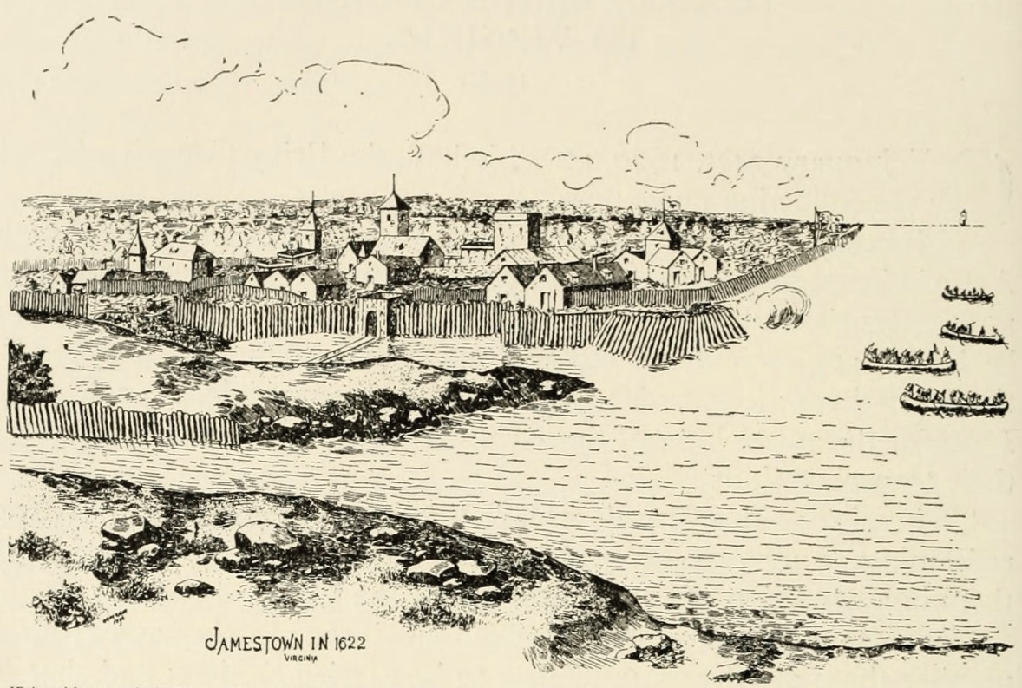

Jamestowne Society https://www.jamestowne.org/
The Jamestowne Society is another “membership by invitation” society. The first step to becoming a member is to contact someone you know who is already a member and they will start the membership process. Other requirements include an autobiographical sketch, and then of course, proof of lineage. Full membership application details are provided on their website.
The scope of their focus is detailed in their mission statement: “To unite descendants of Jamestown settlers prior to 1700, support archaeological excavations at Jamestown, provide educational programming and publications, conserve official documents from the colonial period, and promote the significance of Historic Jamestowne in the founding and shaping of our nation.”
SUMMARY
The lineage and hereditary societies discussed here are the major United States national societies. There also exist single-ancestor or single-family societies and category-based lineage societies.
Some examples of single-ancestor or single-family societies are:
- Descendants of William Brewster - https://www.brewsterfamily.org/
- Boone Family Association - https://boonesociety.org/
- Descendants of George Washington’s Family (Must descend from Washington’s siblings; true single-ancestor branches) - https://www.washingtonfamilydescendants.org/
And examples of category-based lineage societies are:
- Huguenot Society of America - https://www.huguenotsocietyofamerica.org/
- Society of the War of 1812 - https://gswar1812.org/
- Society of Descendants of the Founders of Hartford - https://www.foundersofhartford.org/
As we commemorate the 250th birthday of our great nation, we each can take this opportunity to learn about and reflect on our families past contributions and our individual present-day contributions. It is a good time to ask ourselves what we are doing today that will make our families of the future want to know about and celebrate us.
Price Genealogy is ready to help you with your family history, research and document your ancestry for lineage society membership, and assist with the applications. Let’s celebrate this 250th birthday together.
Christine

DVIDSHUB, “Fleet Week 2012 [image 1 of 7],” photograph of the Ecuadorian navy sail training ship BAE Guayas sails past the Statue of Liberty, uploaded 2012, Openverse, flickr.com (https://www.flickr.com/photos/28650594@N03/7268775984: accessed 17 February 2026.)
“The General Society of Mayflower Descendants,” The General Society of Mayflower Descendants, The Mayflower Society (https://themayflowersociety.org/), mission statement, accessed 16 February 2026.
“The General Society of Mayflower Descendants,” How to Join the Mayflower Society, The Mayflower Society (https://themayflowersociety.org/join/join/), general information, accessed 16 February 2026.
Emily Payson, “Mayflower Meetinghouse Project: Tower Bells Restoration,” About, News and Events, The Mayflower Society (https://themayflowersociety.org/news-events/mayflower-meetinghouse-restoration-project-tower-bells/), accessed 16 February 2026.
Kenneth C. Zirkel, “Lexington Minute Men start off the 2025 Patriots’ Day Parade,” photograph of Patriots’ Day Parade, uploaded 2025; Minute men, Wikimedia Commons, (https://upload.wikimedia.org/wikipedia/commons/f/f6/Lexington_Minute_Men_start_off_the_2025_Patriots%27_Day_Parade.jpg; accessed 17 February 2026).
Daughters of the American Revolution. “Home.” DAR.org, https://www.dar.org. Accessed 16 Feb. 2026.
Daughters of the American Revolution. “Join.” DAR.org, https://www.dar.org/about-dar/join-dar. Accessed 16 Feb. 2026.
Daughter of the American Revolution. “Outreach.” DAR.org, https://www.dar.org/outreach. Accessed 16 February 2026.
Sons of the American Revolution. “Home.” SAR.org, https://www.sar.org. Accessed 16 February 2026.
Sons of the American Revolution. “Home.” SAR.org, https://www.sar.org. Accessed 16 February 2026.
The Colonial Dames of America. “Ancestor Service Eligibility List.” CDA1890.org, https://cda1890.org/ancestor-service-eligibility-list/. Accessed 16 Feb. 2026.
The Colonial Dames of America. “Home.” CDA1890.org, https://cda1890.org/. Accessed 16 Feb. 2026.
The Society of the Cincinnati. “Membership Overview.” SocietyoftheCincinnati.org, https://www.societyofthecincinnati.org/membership-overview/. Accessed 16 Feb. 2026
The Society of the Cincinnati. “Home.” SocietyoftheCincinnati.org, https://www. Societyofthecincinnati.org/. Accessed 16 February 2026.
The Society of the Cincinnati. “Membership Overview.” SocietyoftheCincinnati.org, https://www.societyofthecincinnati.org/membership-overview/. Accessed 16 Feb. 2026
The Society of the Cincinnati. “Institution: The Society of the Cincinnati.” SocietyoftheCincinnati.org, https://www.societyofthecincinnati.org/institution-the-society-of-the-cincinnati/. Accessed 16 Feb. 2026.
See footnotes 1, 2, 5. Footnote 7 however does record that the Sons of the American Revolution also work to educate and inspire future generations about the founding principles of the American Revolution.
Peter Vander (via Conway Whittle Sams), illustration from Conquest of Virginia, the Third Attempt, 1610–1624: Virginia Founded Under the Charters of 1609 and 1612, published from original documents by the Virginia Company of London; Public Domain, Wikimedia Commons, ( (commons.wikimedia.org in Bing) accessed 17 February 2026).
Jamestowne Society. “Application Process.” Jamestowne.org, https://www.jamestowne.org/application-process.html. Accessed 16 February 2026.
Jamestowne Society. “Mission.” Jamestowne.org, https://www.jamestowne.org/mission.html. Accessed 16 Feb. 2026.

